CELA-Outlook-Tag-Management:  
Adding a developer certificate to test the Outlook add in locally

Access the Properties of CELA-Email_Tags_Outlook_Plugin project in the solution.

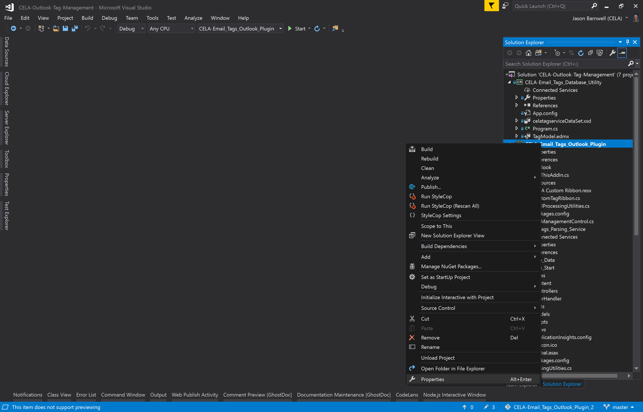

Go to the Signing tab.

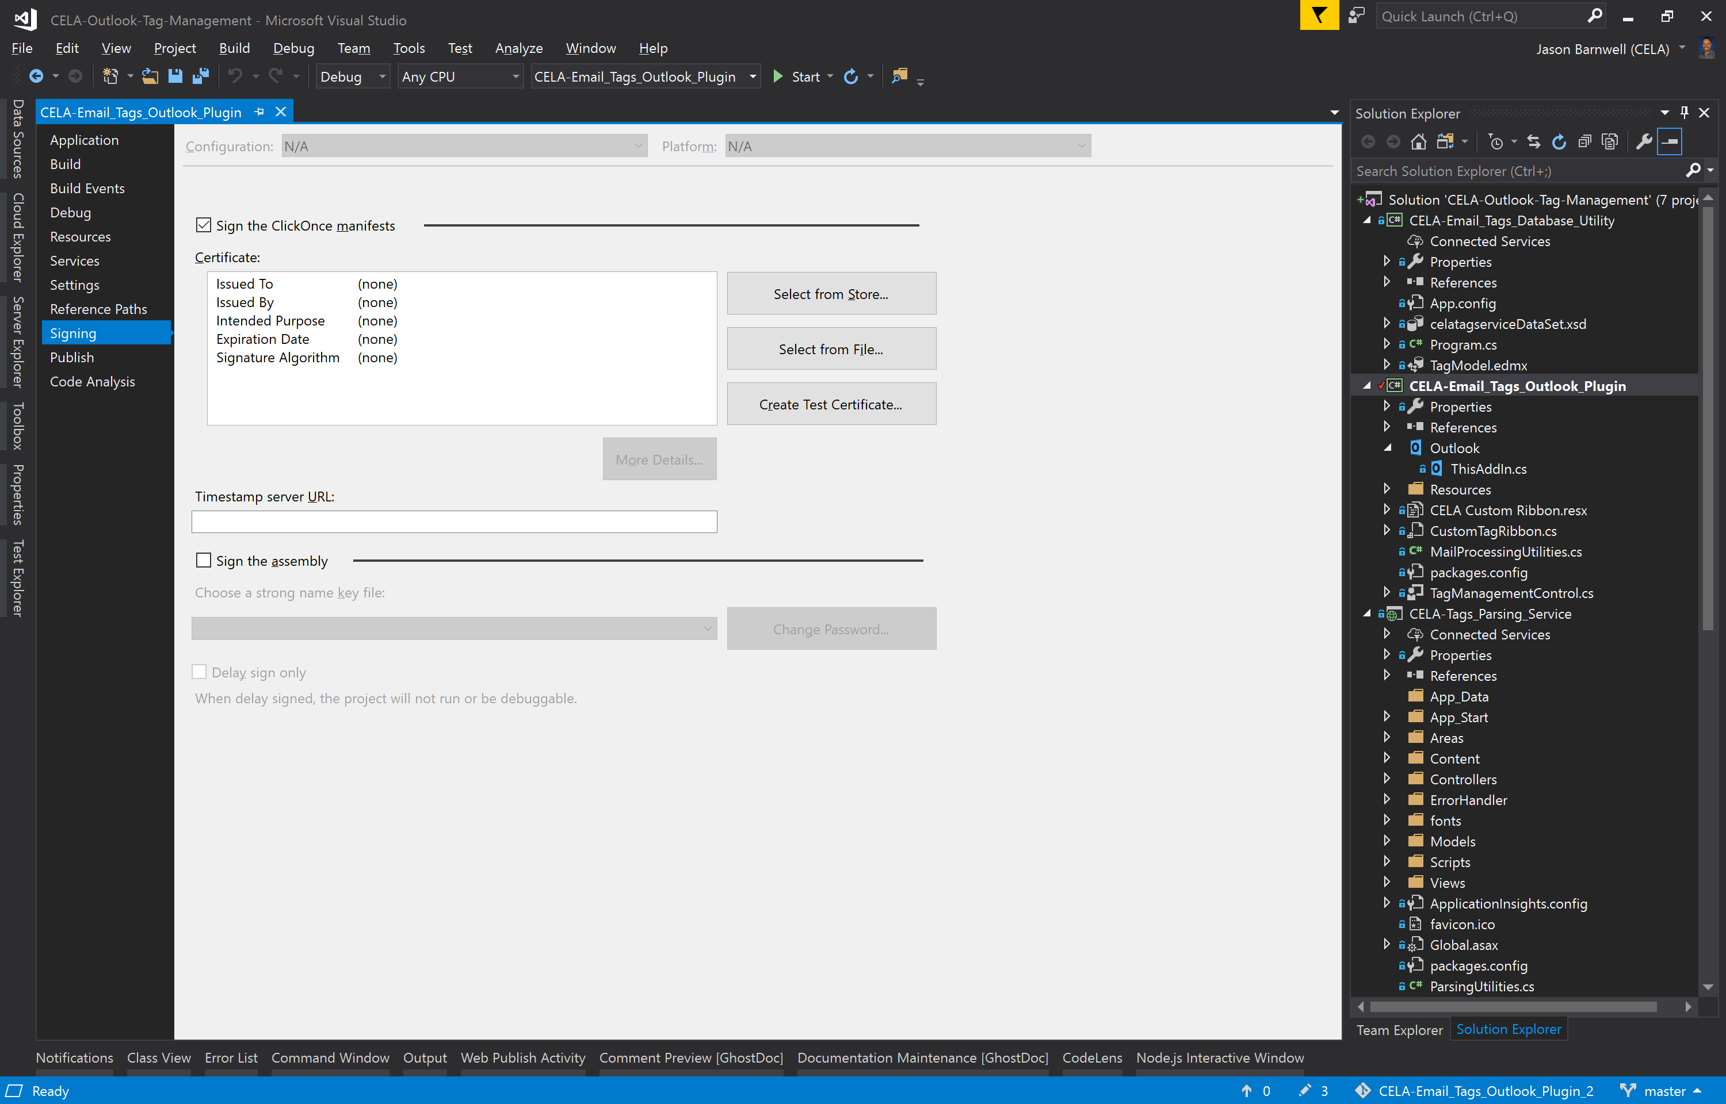

Create Test Certificate

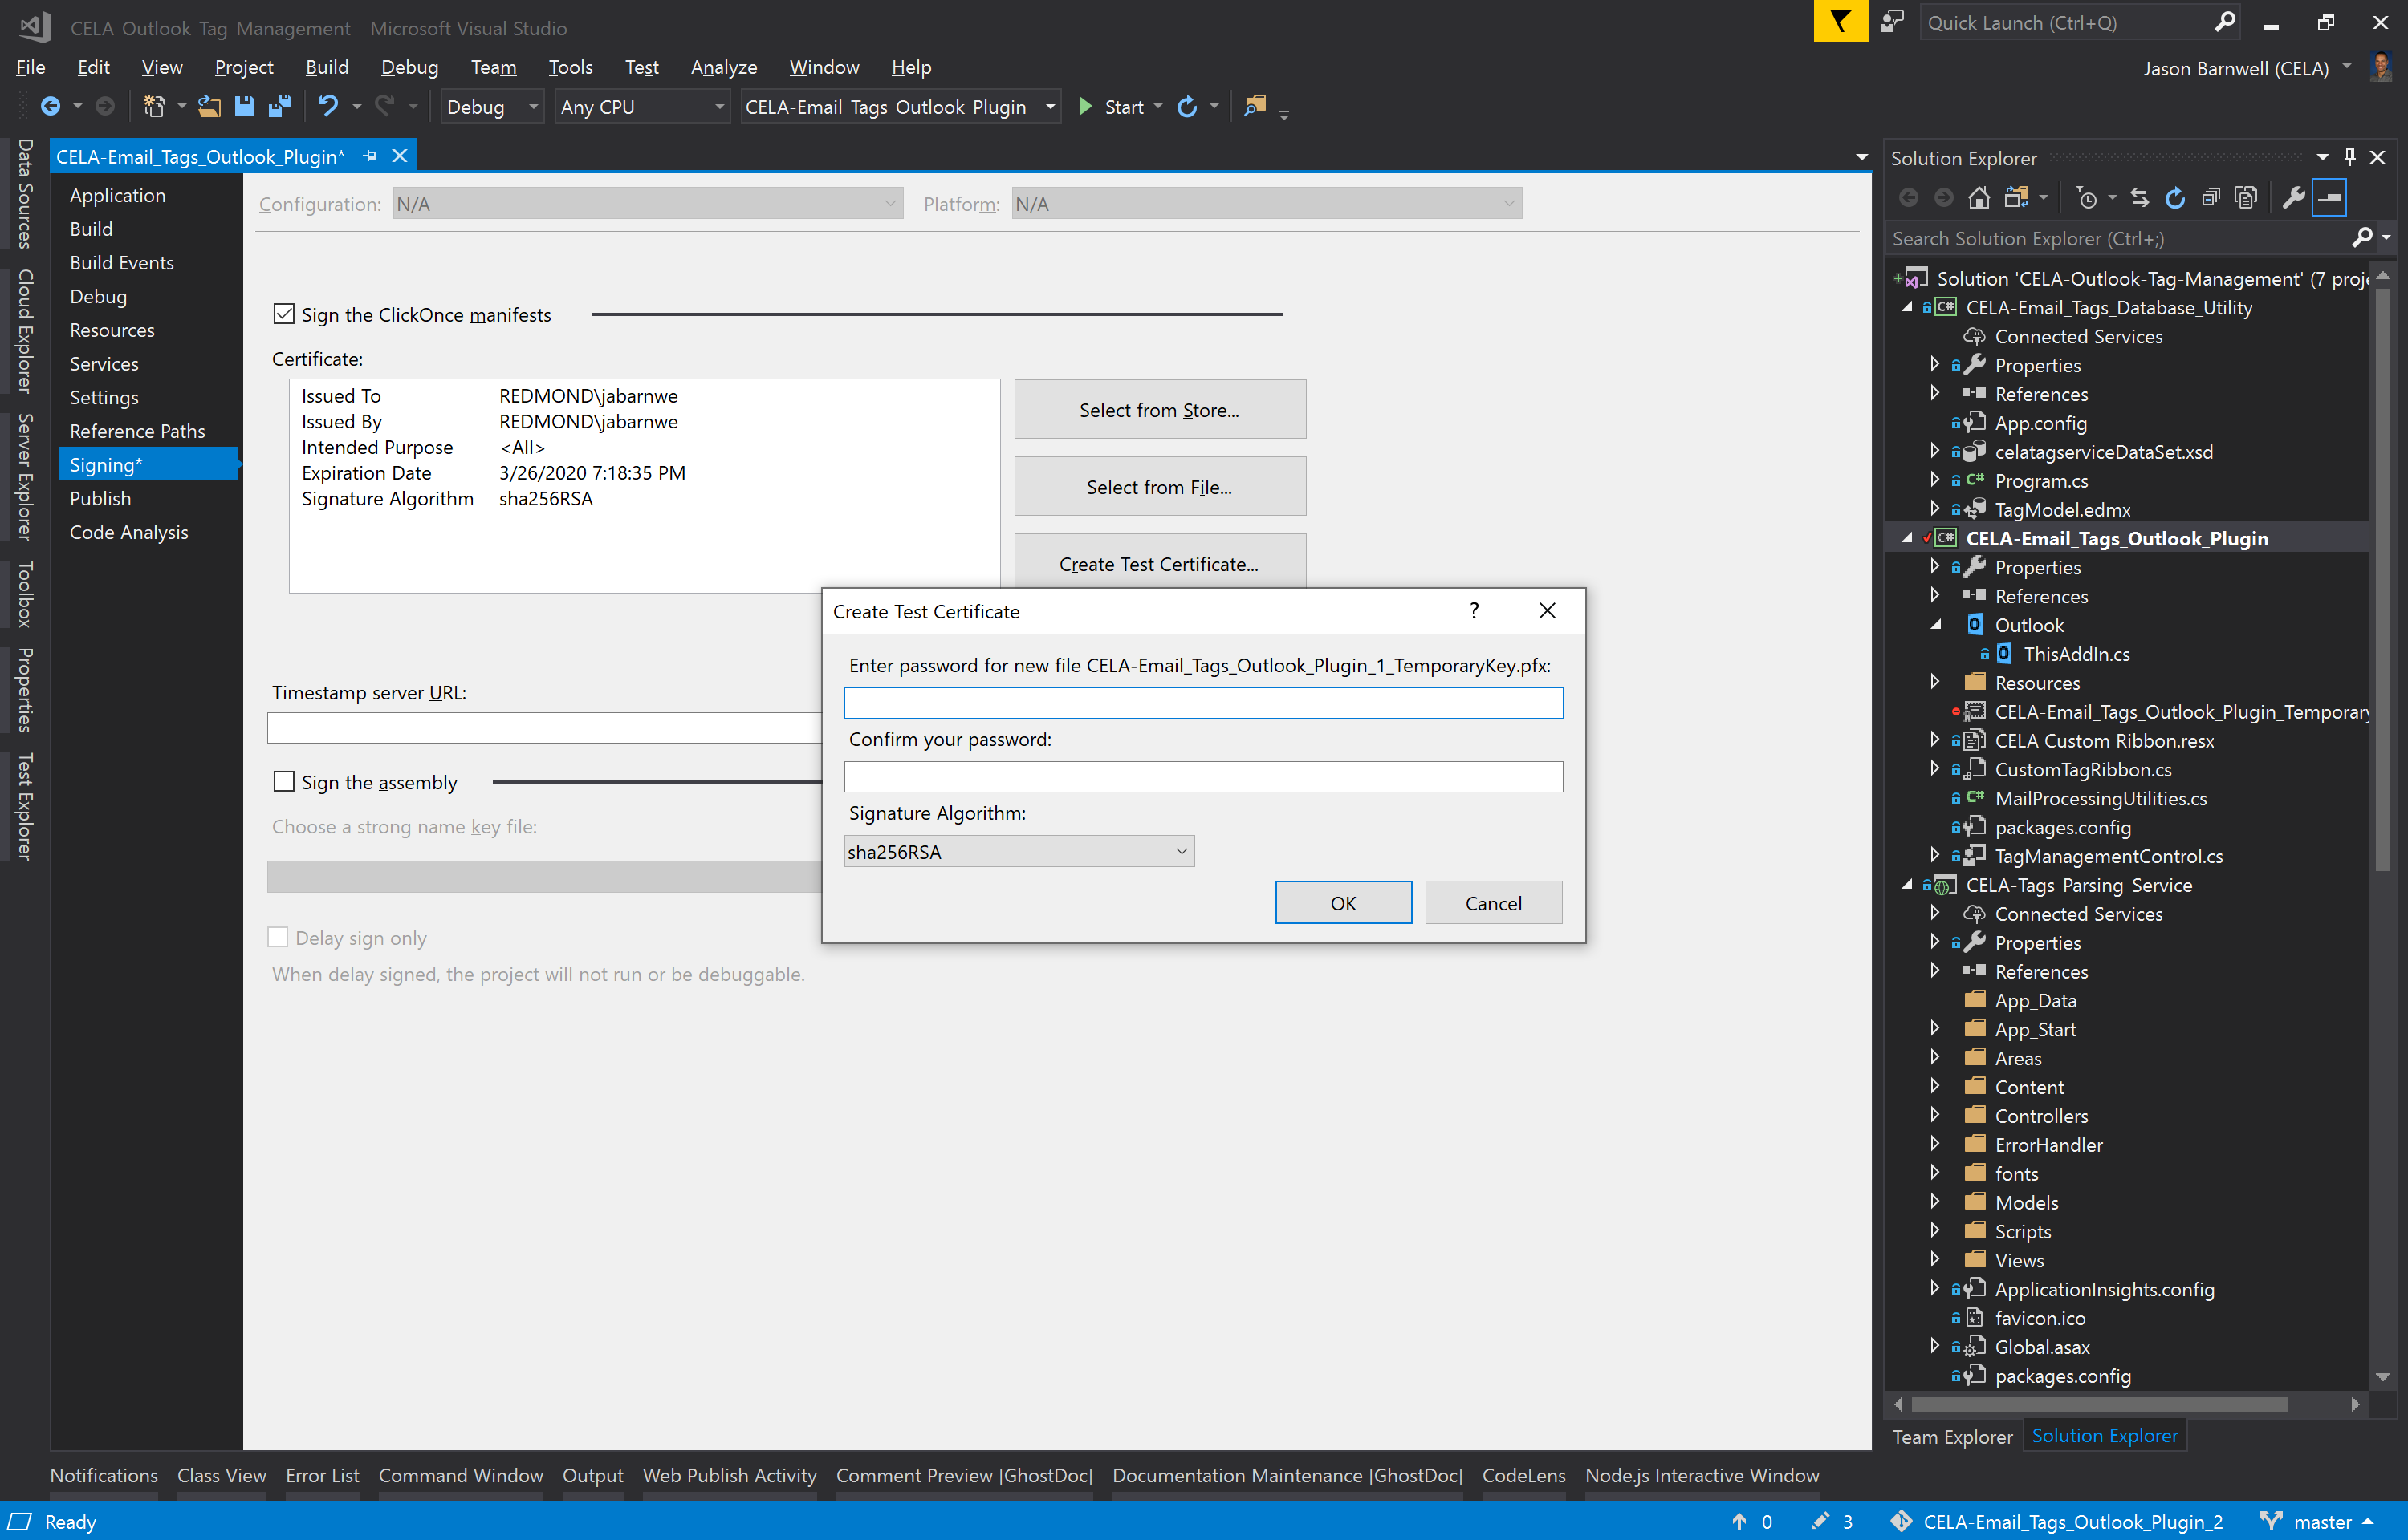

When you build and run the CELA-Email_Tags_Outlook_Plugin project you should see a new CELA Custom element added to the ribbon. Clicking “Add Tags” should add the selected tag to the email.

